**Inversse problem of creating IFS transformations**

Introduction:

In the last chapter we have seen that IFS is a set of contractive transformarion. The limiting set of points of the transformation is called strange attractor. One important feature of such attractor is that it is self similar in nature. That is the the whole is made up of scaled, reflected , rotated and translated versions of original picture. In this chapter , we formally define and describe such transformation and then describe ways of finding set of transformation required for creating such self similar pictures.

**Mathematics of transformation** A transformation is a general term for four specific ways to manipulate the shape of a point, a line, or shape. The original shape of the object is called the pre-image and the final shape and position of the object is the image under the transformation.

Types of transformations in math are:

Scaling

Rotation

Reflection

Translation

A compositions of transformations means that two or more transformations will be performed on one object. For instance, we could perform a reflection and then a translation on the same point.

**Scalings**

Scaling is a kind of transformation in which the size of an object is changed. Remember the change in size does no mean any change in shape. This kind of transformation can be carried out for polygons by multiplying each coordinate of the polygon by the scaling factor r and s where the

scaling factor in the x-direction is denoted r.

scaling factor in the y-direction is denoted s.

As per usual phenomenon of scaling an object moves closer to origin when the values of scaling factor are less than 1.

Assume there are no rotations. Then if r = s, the transformation is a similarity(uniform scaling) otherwise it is an affinity (differential scaling)

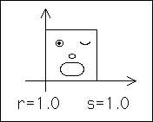 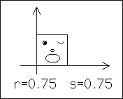

Figure 1. Uniform scaling

 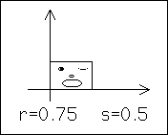

Figure 2 Differential scaling

In matrix form , the transformation is



Note the scalings are always with respect to origin. Therefore, the origin is the fixed point of all scalings.

**Reflections**

Reflection is nothing more than a rotation of the object by 180o. In case of reflection the image formed is on the opposite side of the reflective medium with the same size. Therefore we use the identity matrix with positive and negative signs according to the situation respectively.

The reflection about the *x-axis* can be shown as: 

The reflection about the *x-axis* can be shown as: 

Thus Negative r reflects across the y-axis and negative s reflects across the x-axis.

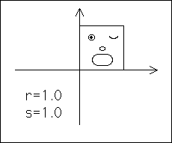 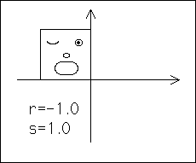

 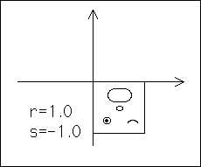

Figure Reflection across y-axis and x-axis

Reflection across both the x- and y-axes is equivalent to rotation by 180° about the origin.

**Rotations**

A rotation is a transformation in which the object is rotated about a fixed point. The direction of rotation can be clockwise or anticlockwise.

The fixed point in which the rotation takes pace is called the centre of rotation. The amount of rotation made is called the angle of rotation.

Let the angle θ measures rotations of horizontal lines and Let the angle φ measures rotations of vertical lines

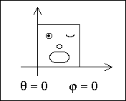 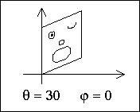

 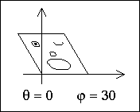

Figure differential Rotation (also called shear)

The condition θ = φ gives a rigid rotation about the origin. Positive angles are counterclockwise.

 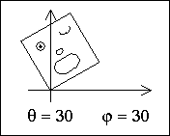

Figure Rigid Rotation

In matrix form , the general rotation transformation is

 and  in case of rogid rotation

**Translations**

In a translation transformation all the points in the object are moved in a straight line in the same direction. The size, the shape and the orientation of the image are the same as that of the original object. Same orientation means that the object and image are facing the same direction.

Horizontal translation is measured by e.

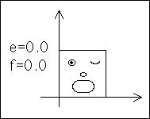 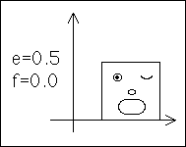

Vertical translation is measured by f.

 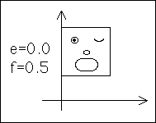

Figure Translation Transformation

In matrix form translation is

 = 

**Combined Matrix formulation**

This is the matrix formulation for the transformation that involves scaling by r in the x-direction, by s in the y-direction, rotations by theta and phi, and translations by e and f.

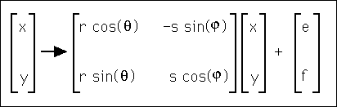

Thus each transformation can be encoded as



It may be also noted that  may be replaced a,b,c,d where

. Most implementations it is efficient use parameters as a,b,c,d,e,f

**The Inverse Problem**

As you can see from the IFS fractal images we can create spectacular images using iterated function systems. But how does one discover the appropriate tranformations and probabilities required to build the object? How were the transformations created?

Michael Barnsley described a technique in his presentation called the Collage Theorem. The idea of the Collage Theorem is simple: cover the object with a collection of objects that are scaled, reflected, rotated, or translated copies of the original. Then find the required transformations. Many cases, we can find the transformation by careful observation itself.

Mathematically, given a fractal F, the Inverse problem is to find affine transformations T1, ..., Tn for which F = T1(F) ∪ ... ∪ Tn(F). Here we present a method to solve this problem, as well as one implementations of the method.

Remarkably, solving the inverse problem has only two steps:

1. Using the self-similarity (or self-affinity) of F, decompose F as F = F1 ∪ ... ∪ Fn, where each Fi is a scaled copy of F.

2. For each piece Fi, find an affine transformation Ti for which Ti(F) = Fi. By "find an affine transformation" we mean find the r, s, θ, φ, e, and f values.

Examples and Practice Problems

For practice recognizing reflections and rotations, we consider two examples.

Example 1.

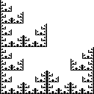 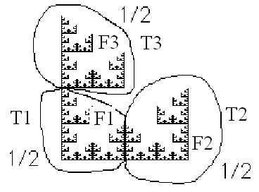

Figure IFS Fractal F Fractal decomposition 

Here 

 is obtained by scaling ;  is obtained by scaling , followed by its reflection about y axis and then translation in x-direction. is obtained by scaling  followed by a translation in y-direction.

Figure below shows the required translation and color coded regions.

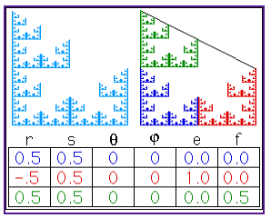

Figure

**IFS Example 2**

This fractal can be decomposed into three pieces:

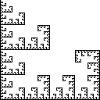 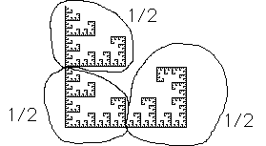

Figure

Note the top and bottom left pieces have the same orientation as the entire fractal, while the bottom right piece is rotated.

Figure below shows required transformation

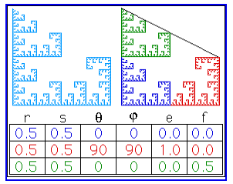

Figure

A tricky Tricky Decompositions

At first look , we feel that it is an infinite array of sierpinski triangle but a closer look at the figure reveals only 3 transformations are required as the whole figure can be decomposed into 3 scaled versions of the original. Can you find the required transformation.

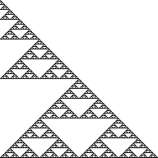 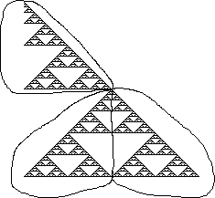

Figure

If finding a decomposition is difficult, there are two approaches for building intuition. The first uses paper and scissors, the second uses straight forward algebra.

First approach:

(a) Trace the main features of the fractal and cut out smaller copies of the tracing.

(b) To allow for reflections, flip the small copies and on the back trace over the lines on the front. Label the front image with a small F, to distinguish it from its reflection, and to indicate the original orientation.

(c) Place the small copies, perhaps rotating or reflecting them, to make a copy of the original fractal.

Fern

The fern may be a puzzle: it appears to be made of many, many small ferns along the central stem. Yet we need only four rules to build the fern. See the color figure in the attached CD

 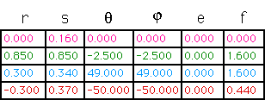

Figure Fern and its IFS transformations

Second approach

In Figure, note that we have drawn a red triangle similar in size and shape to the fern. Then loosely cover the fern (and the red triangle) with four green transformed copies of the red triangle (the green stem is a very narrow copy of the red triangle).

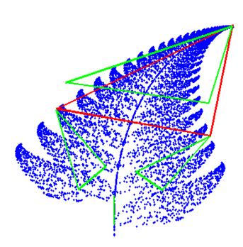 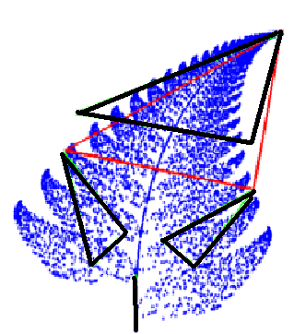

Figure Fern leaf with four transformations

We will find Affine Transformations.

Recall that an affine transformation has the following form:

x' = ax + by +e y' = cx + dy + f (eq 1)

Example Suppose that you wish to find the transformation that maps triangle ABC to triangle A'B'C' in Figure below.

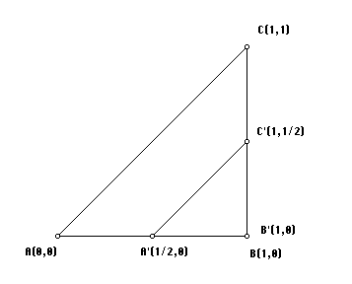

Figure Finding affine transformations

You need to find the tranformation that sends A(0,0) to A'(1/2,0) , B(1,0) to B'(1,0) and C(1,1) to C'(1,1/2). The affine transformation (1) has to send A(0,0) to A'(1/2,0). Substitute the coordinates of point A(0,0) (the preimage) into x and y and susbstitute the coordinates of the point A'(1/2,0) (the image) into x' and y'.

1/2 = a(0) + b(0) +e ; 0 = c(0) + d(0) + f (2)

Because B(1,0) gets "sent" to B'(1,0), substitute the coordinates of the point B(1,0) into x and y of equation (1) and the coordinates of the point B'(1,0) into x' and y'.

1 = a(1) + b(0) + e; 0 = c(1) + d(0) + f (3)

Finally, substitute the coordinates of the point C(1,1) into x and y of equation (1) and the coordinates of the point C'(1,1/2) into x' and y'.

1 = a(1) + b(1) + e ; 1/2 = c(1) + d(1) + f (4)

The substitutions made in (2), (3), and (4) lead to six equations in six unknowns. There are a variety of techniques available that will allow you to solve the six equations in (2), (3), and (4) for the unknowns a, b, c, d, e, and f. The solution of the equations in (2), (3), and (4) is a = ½; b = 0; c = 0; d = ½; e = ½; f = 0

Substitute these values into the affine tranformation (1) to get the following result.

x' = (1/2)x + 0y + (1/2); y' = 0x + (1/2)y + (0) (5)

Here we obtain constants a,b,c,d,e,f

Approximate values of r,s, theata, phi can be obtained on further algebraic manipulation.

Following coloured figures illustrate the inverse problem in IFS

Following figure shows self similar tree and its self-similar parts.. Although stem is not self similar to the tree , we can find an affinte transformation that maps the tree to stem.

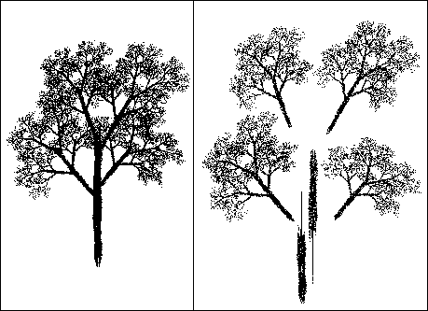

**Figure Self Similar Tree**

The coloured tree fragments and corresponding transformation

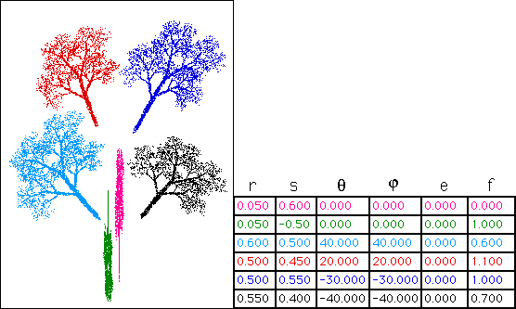

**Queen Anne's Lace IFS**

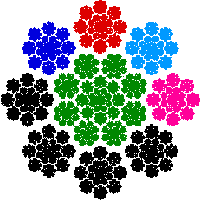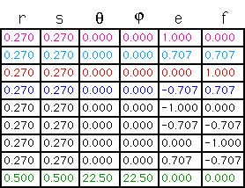

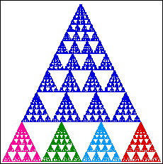 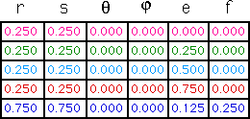

**Snow IFS**

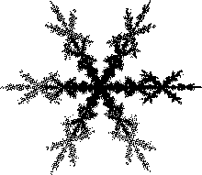 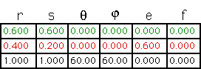

More IFS

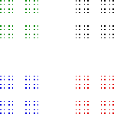

r s θ φ e f

.333 .333 0 0 0 0

.333 .333 0 0 .667 0

.333 .333 0 0 0 .667

.333 .333 0 0 .667 .667

Figure Fractal and its IFS

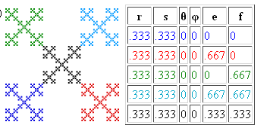

Figure Fractal and its IFS

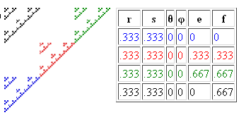

Figure Fractal and its IFS

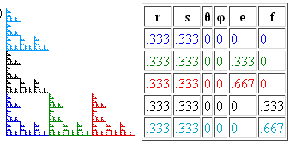

Figure Fractal and its IFS

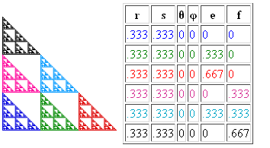

Figure Fractal and its IFS

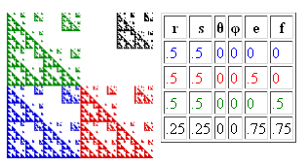

Figure Fractal and its IFS

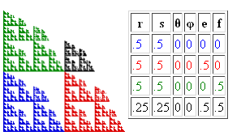

Figure Fractal and its IFS

Figure Fractal and its IFS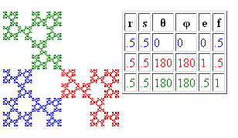

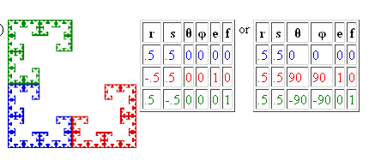

Figure Fractal and its IFS

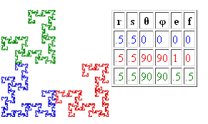

Figure Fractal and its IFS

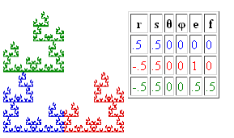

Figure Fractal and its IFS

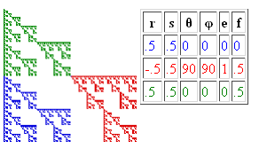

Figure Fractal and its IFS

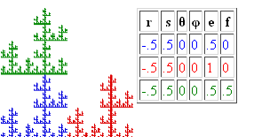

Figure Fractal and its IFS

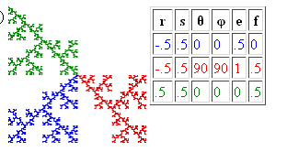

Figure Fractal and its IFS

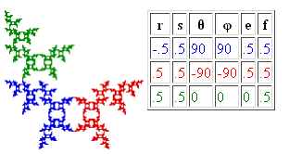

Figure Fractal and its IFS

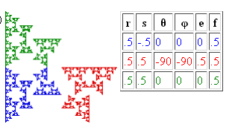

Figure Fractal and its IFS

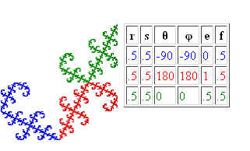

Figure Fractal and its IFS

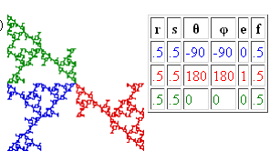

Figure Fractal and its IFS

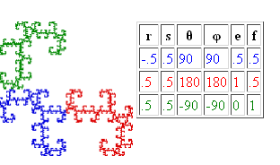

Figure Fractal and its IFS

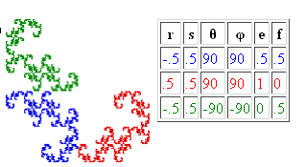

Figure Fractal and its IFS

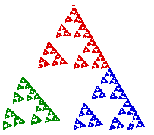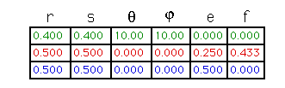

Figure Fractal and its IFS

**Spiral Fractals and their IFS transformations**

Spiral 1

r s θ φ e f prob

T1 0.29 0.29 0 0 0.71 0.41 0.11

T2 0.83 0.83 20 20 0 0 0.89

Spiral 2



r s θ φ e f prob

T1 0.3 0.3 0 0 0.7 0 0.1

T2 0.3 0.3 0 0 -0.7 0 0.1

T3 0.85 0.85 20 20 0 0 0.8

**Spiral 3**

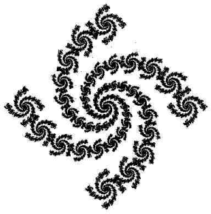

r s θ φ e f prob

T1 0.2 0.2 0 0 0.8 0 0.05

T2 0.2 0.2 0 0 -0.8 0 0.05

T3 0.2 0.2 0 0 0 0.8 0.05

T4 0.2 0.2 0 0 0 -0.8 0.05

T5 0.85 0.85 20 20 0 0 0.8

Spiral 4

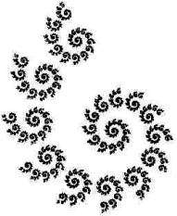

r s θ φ e f prob

T1 0.3 0.3 0 0 -.36 0.7 0.1

T2 0.9 0.9 30 30 0 0 0.9

Spiral 5

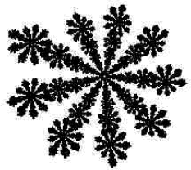

r s θ φ e f prob

T1 0.25 0.25 0 0 -.75 0.3 0.1

T2 0.95 0.95 40 40 0 0 0.9

Spiral 6

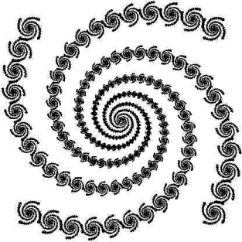

r s θ φ e f prob

T1 0.1 0.1 0 0 0.75 0.75 0.02

T2 0.1 0.1 0 0 -0.75 -0.75 0.02

T3 0.1 0.1 0 0 -0.75 0.75 0.02

T4 0.1 0.1 0 0 0.75 -0.75 0.02

T5 0.95 0.95 10 10 0 0 0.92

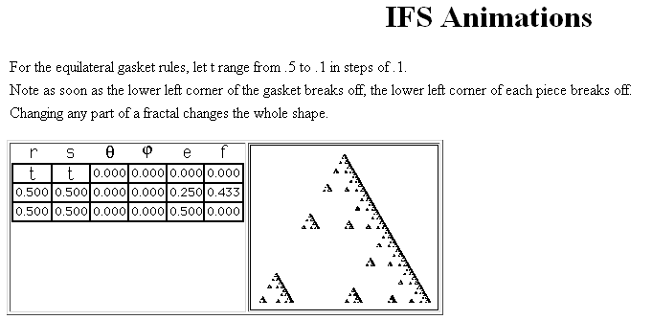

37

For the equilateral gasket rules, let t range from 0 to 360 in steps of 10°.

Note the lower left corner (both blues) makes one complete rotation, the lower left corner of the lower left corner (dark blue) makes two complete rotations.

The lesson here is that each subpiece is viewed relative to the larger part.

The dark blue is the lower left corner of both blues, so makes one rotation relative to both blues.

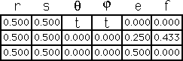

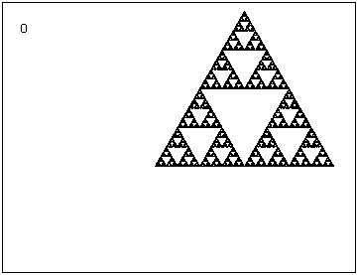

38

Here we spin the lower left corner CCW and the lower right corner CW in 10° steps.

To maintain the symmetry of the left and right corners, we translate the left corner by e = A = 1 - 0.5⋅cos(-t) and f = B = -0.5⋅sin(-t).

What do you notice about the motion of the three subpieces of the lower corners?

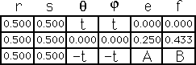

39

To illustrate how a rotation can create a spiral, here we step the rotation of the middle piece from 20° to -20° in steps of 5°.

Again, note the motion within motion of pieces within pieces.

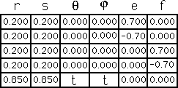 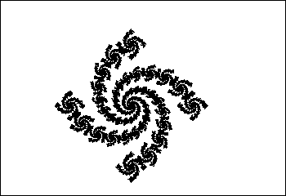

40

Here the scaling factor of the upper right piece ranges between a = 0.5 and a = 0.25, the translation between b = 0.75 and b = 0.5.

Throughout the animation, the unchanging part is the right isosceles Sierpinski gasket. Do you see why?

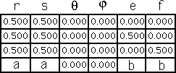

41

Here we move the upper right corner from a translation of b = 0.75 to b = 0.25 in steps of 1/16 = 0.625.

Note how the reflection of the lower right and upper left pieces affects the motion within those pieces

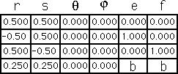

42

Here we let t range between 0 and .375 in steps of 0.125.

Note the motion in each piece is a scaled version of the motion of the whole.

Is the idea of fractal motion beginning to be clear?

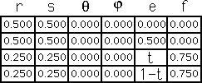

43

Here we investigate the effect of different values for theta and phi.

In this example, θ = t ranges between 90 and 0 in steps of 10°.

Can you give a complete description of the theta = 0 picture?

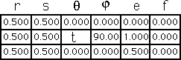

44

Here φ = t ranges between 90 and 0 in steps of 10°.

Can you give a complete description of the phi = 0 picture?

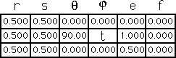

Animations

<http://classes.yale.edu/fractals/IntroToFrac/InvProb/IFSAnimation/IFSAnimation.html>

<http://classes.yale.edu/fractals/IntroToFrac/InvProb/InvProbExamples.html>

http://classes.yale.edu/fractals/IntroToFrac/InvProb/InvProbSteps.html

http://classes.yale.edu/fractals/

Applications